**2nd Exploitation(DODS ATTACK)**

**In this second exploitation we exploited the open operts and make Dods attack on the target ip ie 192.168.68.129**

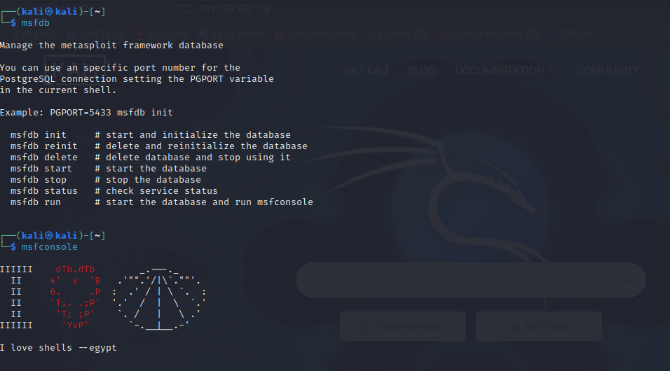

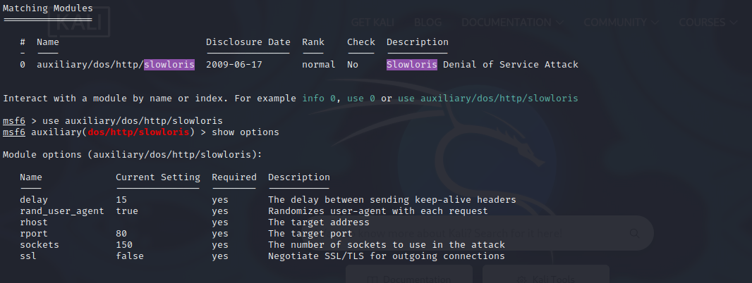

**BEFORE ATTACK**

**AFTER ATTACK**